**UCL Summer School Coursework Coversheet**

Complete and paste this coversheet to the front of your assignment

| **Student candidate number:** KQLP7 |
| --- |
| **Programme**: UCL Summer School |
| **Module:** ISSU0098: Data Driven Web-Based Applications. |
| **Assignment Title**: Individual Coding Assignment |
| **Word Count**: 2000 words  (Excluding abstract, footnotes, bibliography/references list, appendices, tables, figures and title) |

**Student Declaration:**

*By submitting this assessment, I confirm that all the work is my own unless collaboration has been specifically authorised. I understand that any form of* [Academic Misconduct](https://www.ucl.ac.uk/students/exams-and-assessments/academic-integrity) *is strictly prohibited, including the use of essay mills, homework help sites, plagiarism (including self-plagiarism), collusion, falsification, impersonation or any other action which might give me an unfair advantage.* **☐**

| If you have used AI tools in your assignment, please provide a one sentence summary of how it was used:  e.g.  *I used ChatGPT to understand and learn the CSS styling required for creating the webpage, and several further ChatGPT prompts in order to assist in debugging the issues I faced during the coding process.* |
| --- |

I am aware that my assignment may be used in anonymised form in helping future students.

**Opt-out**: do not allow material to be used in teaching future students **☐**

| **Extenuating Circumstances**    Please only complete this section if you have applied for EXTENUATING CIRCUMSTANCES (EC)  *Please tick the relevant box*:   * I have applied for EC but have NOT received a decision from the panel yet **☐** * I have applied for EC and have received a decision from the panel. **☐**   **My new deadline is:** Click or tap to enter a date.  *Please note that after the original deadline whatever you submit will be deposited on Turnitin so you cannot submit multiple times. If you want to check your Turnitin score before you submit you can do this by uploading a ‘test’ submission on the following Moodle page:*  [*https://moodle.ucl.ac.uk/enrol/index.php?id=34*](https://moodle.ucl.ac.uk/enrol/index.php?id=34) |
| --- |

# Table of Contents

**Table of Contents 2**

**Executive Summary 3**

**Original Database 3**

**Improvements Made 4**

Thought Process 4

Interface #1 - The Home Page: 5

Interface #2 - The Registration Page: 7

Interface #3 - The Registration Page 2: 9

Interface #4 - User List Page: 11

Usage of Inspect Function for More Robust Designs: 13

**Further Improvements 14**

**Reflection 14**

**References 14**

**Appendix 14**

# Executive Summary

In this individual coding assignment, I was assigned the task of improving a current database interface that registers details of their users, including their name, age, date of birth, address and etc. These details are then shown to users once they successfully register and log into the system.

My task mainly revolves around ensuring the smooth transitioning between the pages, safe and successful logging of user information into the database, and coming up with a better user interface.

# Original Database

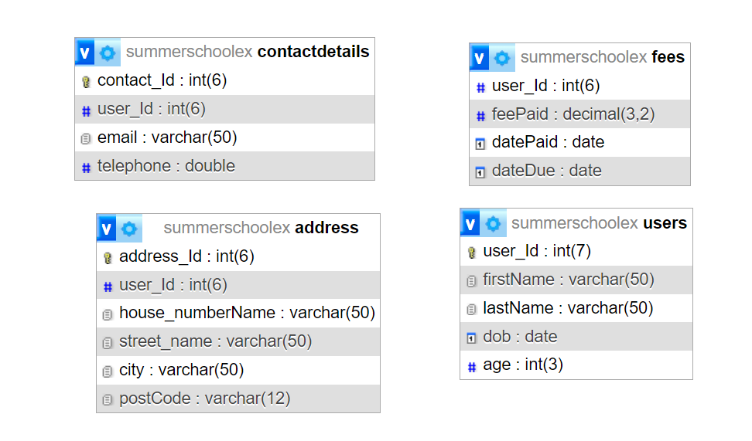

*Figure 1: Web Application Database*

The underlying database is kept unchanged during the process of my website revamp. This is mainly due to the time constraint and my intention of utilising the available resources to come up with a better interface for users to interact with while keeping the underlying structure.

# Improvements Made

### Thought Process

First and foremost, to ensure that our improvements are standardised, we should have some guidelines that we adhere to. Here are some of the guidelines that I have utilised along the way:

1. The colour code adheres to the colour palette of UCL, utilising the colours from UCL for the design and styling
2. I wanted to design this with some more UCL elements involved, in order to showcase my skills and commemorate my time studying in UCL. Thus, some resources, which is referenced in my references, are utilised for that purpose.
3. Given that I do not have a lot of context regarding the background and use case of this interface, minimal changes have been made to the underlying database and its functionalities. However, some improvements are suggested in the further improvements section for reference.
4. I decided to standardise the wording to using Montserrat, as it is one of the most commonly used and neat font available widely.

### Interface #1 - The Home Page:

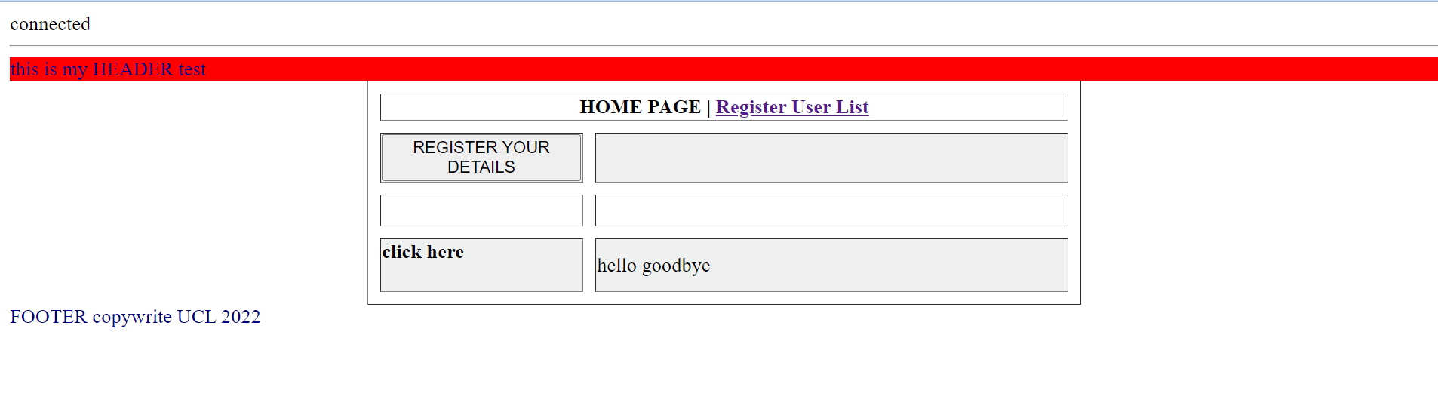

*Figure 2: The Original Home Page Website Interface*

The original home page is relatively disorganised and lacks the proper wording to annotate the page. From the original design, I decided to adopt the use of header and footer in the page, while revamping the table in the middle. It is then redesigned to a simple quiz button for entertainment purposes.



*Figure 3: The Updated Home Page Website Interface*

For the home page, PHP is used to connect with the main database. Jquery is then used to create an interactive quiz button in the centre of the page for entertainment and information. HTML is used extensively in conjunction with CSS styling to ensure that the design and interface is nicely styled.

Attached are snapshots of the parts of the PHP and CSS files used in this page:

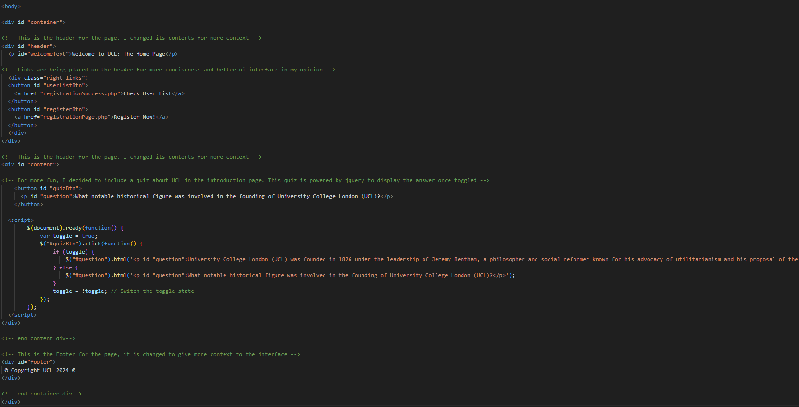

*Figure 4: PHP File for the Updated Home Page Website Interface*

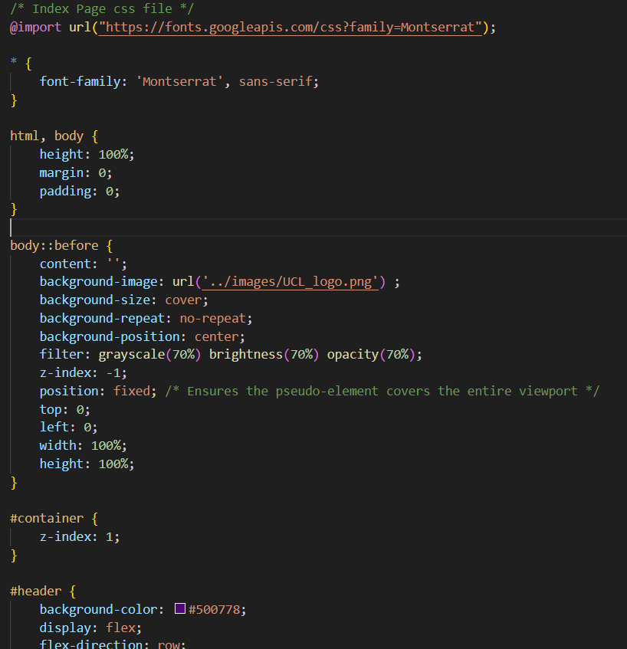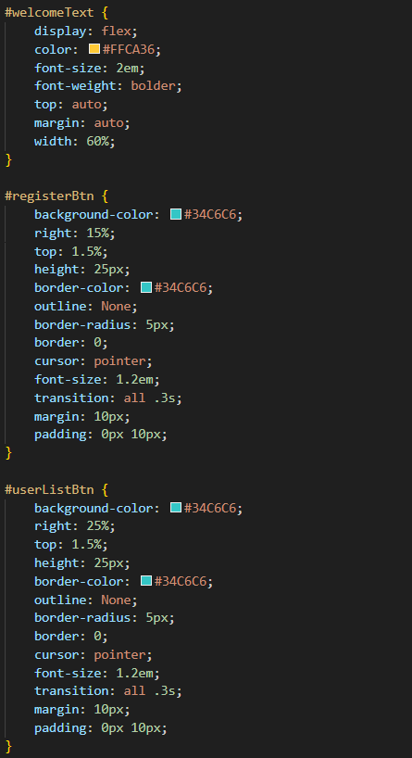

*Figure 5: CSS Stylesheet for the Updated Home Page Website Interface*

### 

### 

### 

### 

### 

### Interface #2 - The Registration Page:

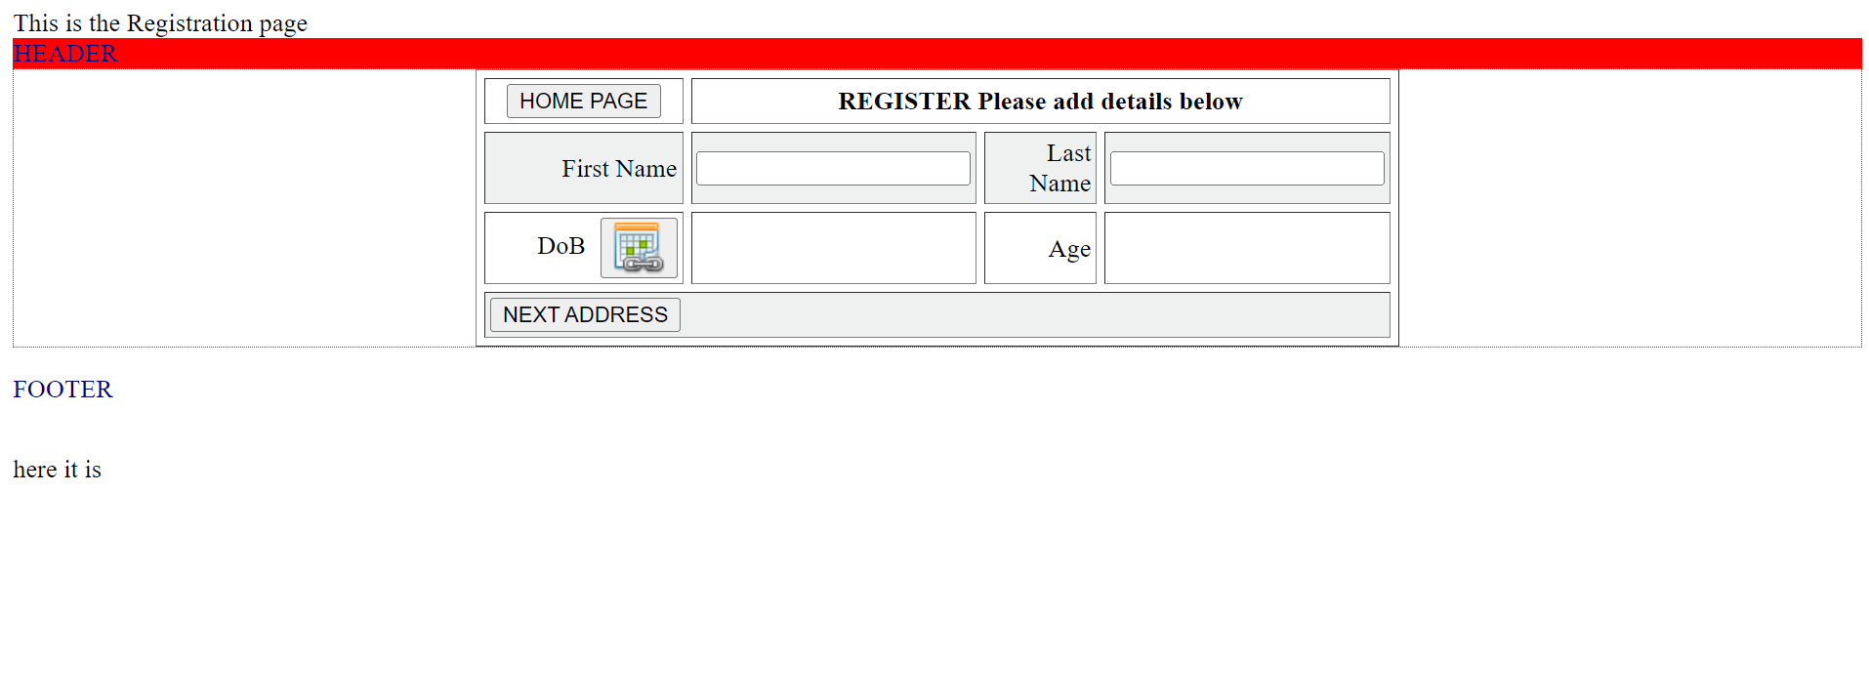

*Figure 6: The Original Register Page 1*

The original registration page 1 is relatively dull, with a table registering the user’s first name, last name, date of birth and age. A few additional words are displayed on the page as well in order to update the status of the database and webpage. However, the wording could have been annotated better and is a source of improvement. The header and footer design are still kept, albeit styled differently.

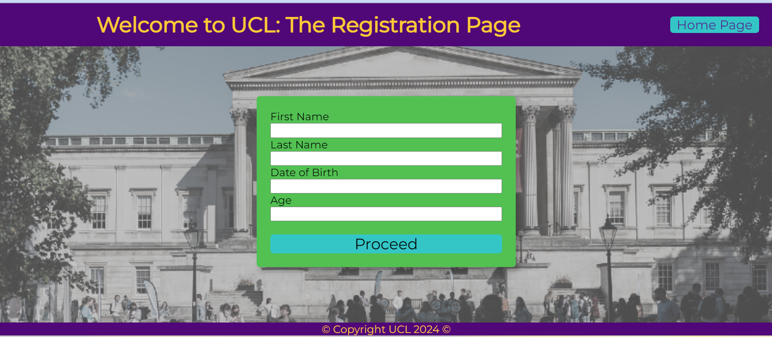

*Figure 7: The Updated Register Page 1*

The updated registration page 1 utilised the header and footer design in the original HTML sheet. However, the home page button is redesigned to be placed on the top right corner. The table interface is then changed to a form interface in the middle of the webpage, as I do think it is a better styling as compared to the original table. The details are displayed in the alert created via Jquery in order to inform users about their actions.

Attached are snapshots of the parts of the PHP and CSS files used on this page:

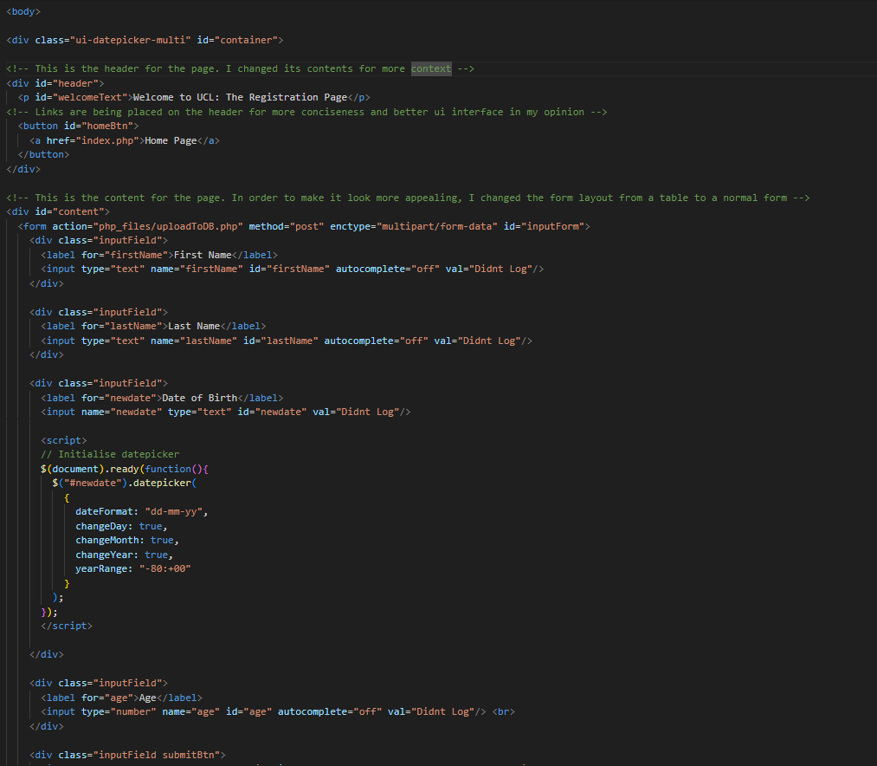

*Figure 8: PHP File for the Updated Register Page 1*

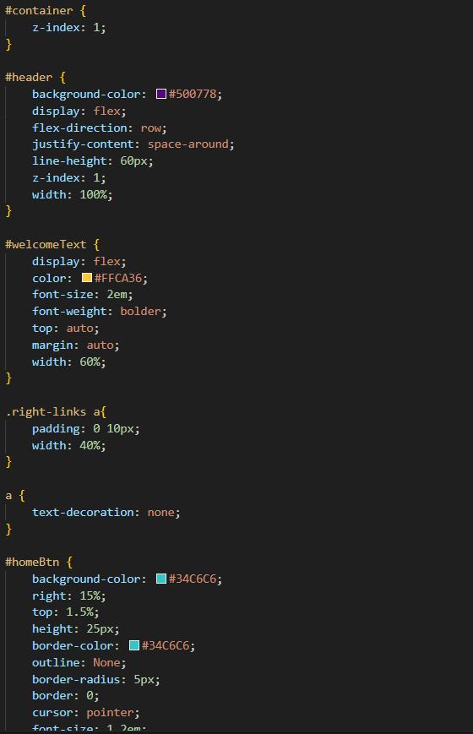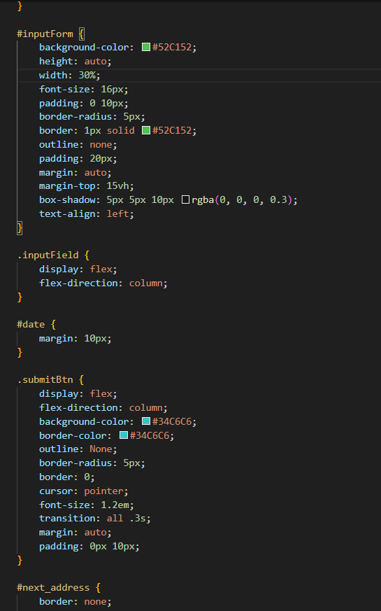

*Figure 9: CSS Stylesheet for the Updated Register Page 1*

### Interface #3 - The Registration Page 2:

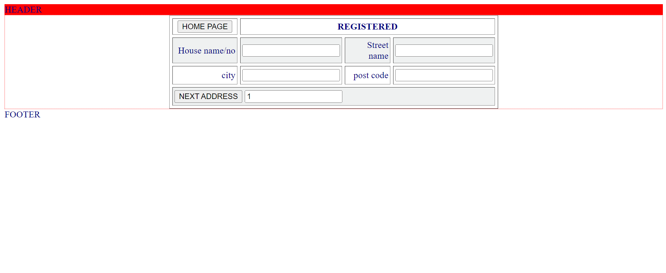

*Figure 10: The Original Register Page 2*

Similar to the original register page 1, this register page is styled similarly. Thus, similar actions are taken to restyle and redesign the interactions between the elements on the page. More precise wording is utilised as well for better context.

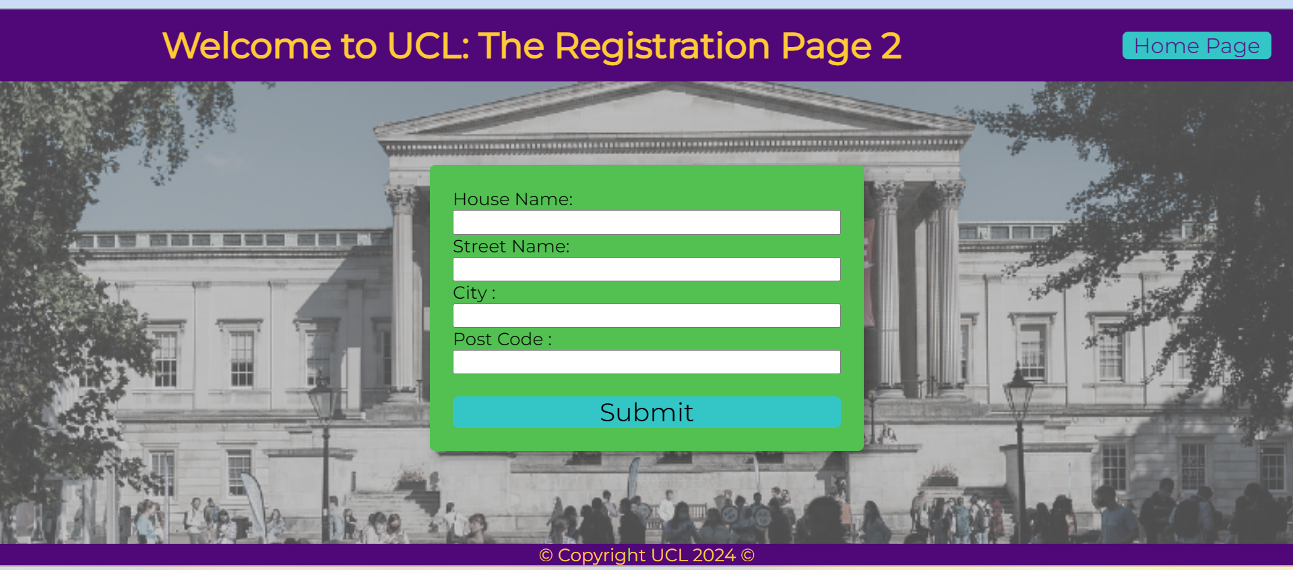

*Figure 11: The Updated Register Page 2*

Similar to its predecessor, the updated registration page 2 utilised the header and footer design in the original HTML sheet. The home page button is also redesigned to be placed on the top right corner. The table interface is then changed to a form interface in the middle of the webpage, as I do think it is a better styling as compared to the original table. The details are displayed in the alert created via Jquery in order to inform users about their actions.

Attached are snapshots of the parts of the PHP and CSS files used on this page:

### 

### 

*Figure 12: PHP File for the Updated Register Page 2*

### 

*Figure 13: CSS Stylesheet for the Updated Register Page 2*

### Interface #4 - User List Page:

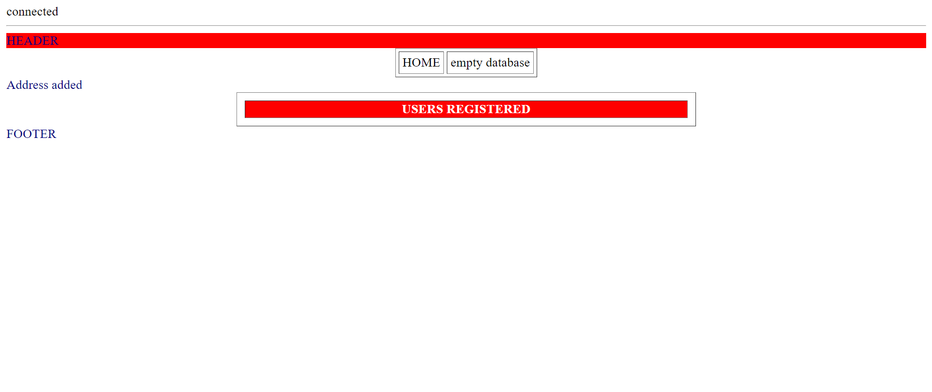

*Figure 14: The Original User List Website Interface*

In the original user list display website, we display each distinct user's details in two rows. This is relatively hard to read and thus is a major point to change. On the other hand, I removed the unnecessary wording on the page and restyled the buttons for a better user experience and standardisation.

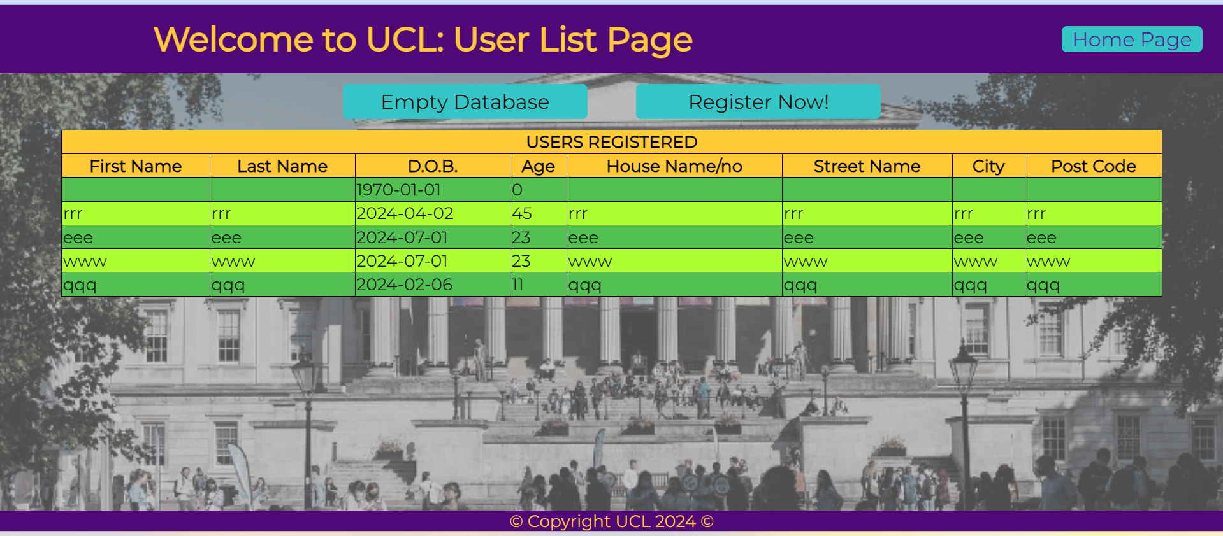

*Figure 15: The Updated User List Website Interface*

As displayed on the updated user list interface, the table is recreated to display all user information in one row. The buttons are redesigned to standardise them with other buttons from other interfaces as well as for a better user experience. The header and footer design remains the same.

Attached are snapshots of the parts of the PHP and CSS files used on this page:

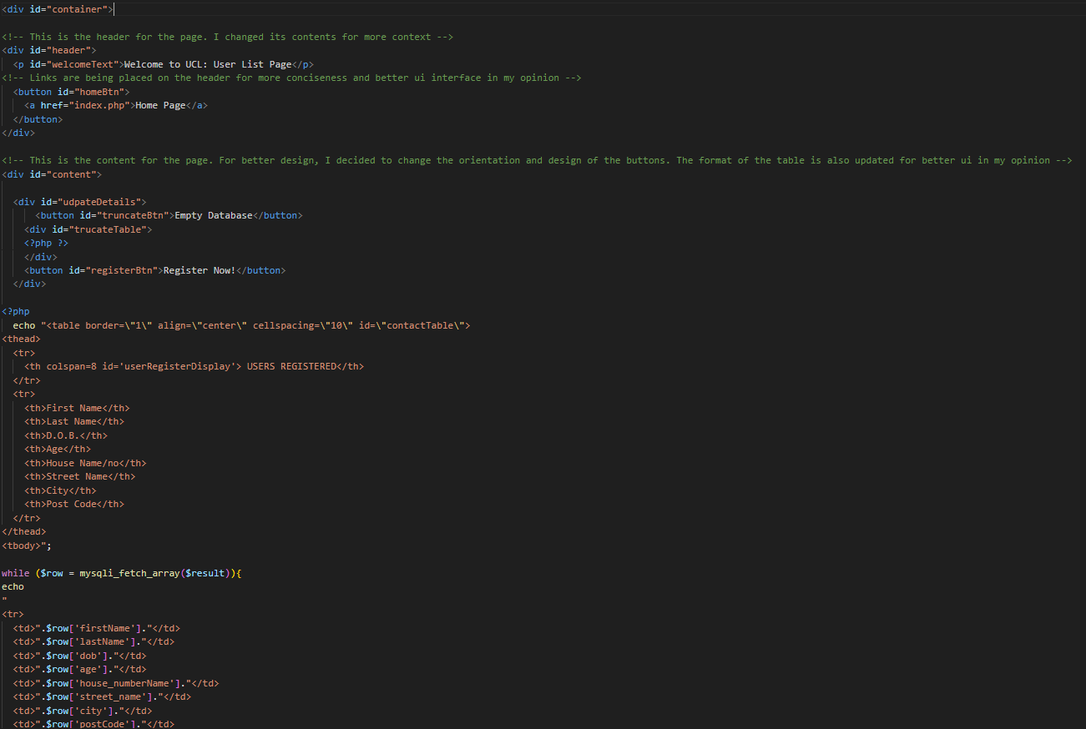

*Figure 16: PHP File for the Updated User List Website Interface*

### 

*Figure 17: CSS Stylesheet for the Updated User List Website Interface*

### 

### Usage of Inspect Function for More Robust Designs:

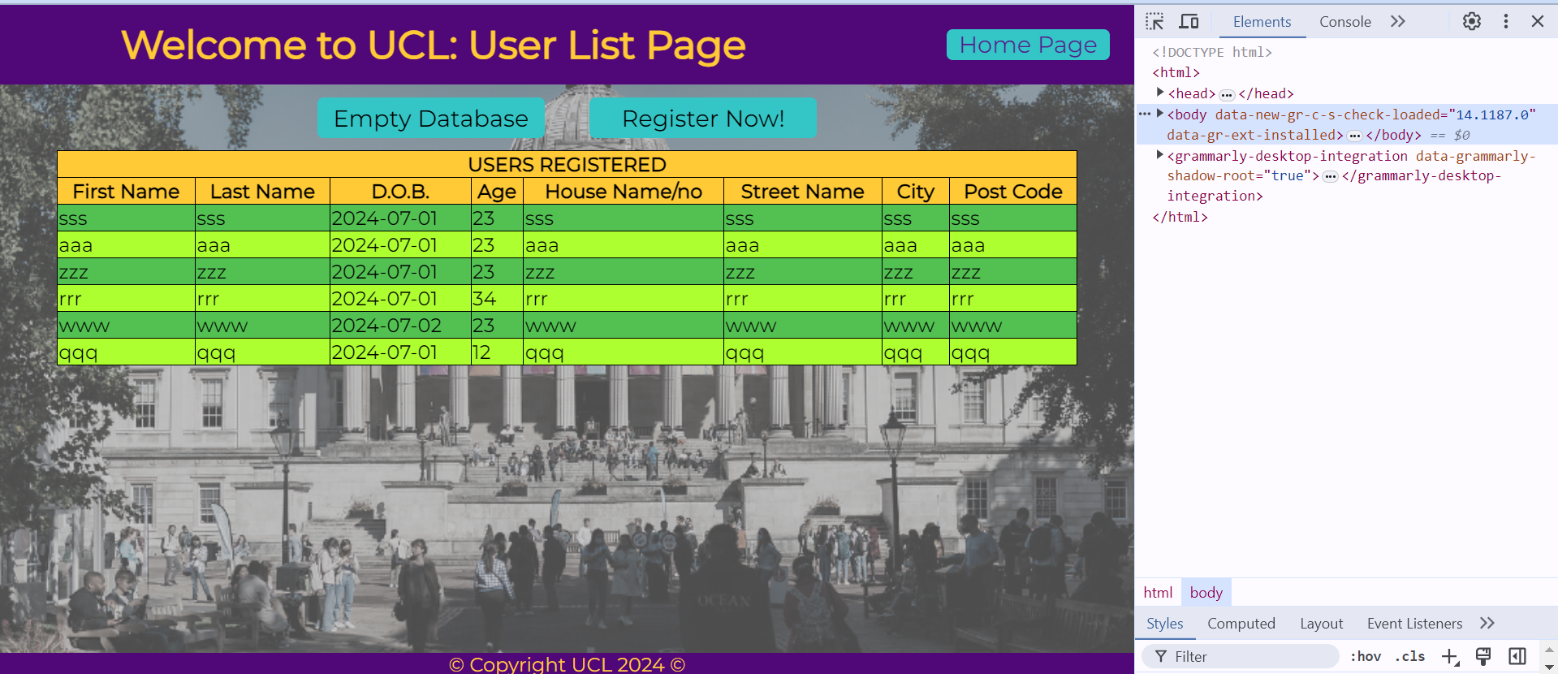

*Figure 18: Usage of Inspect Tool for Element Checking*

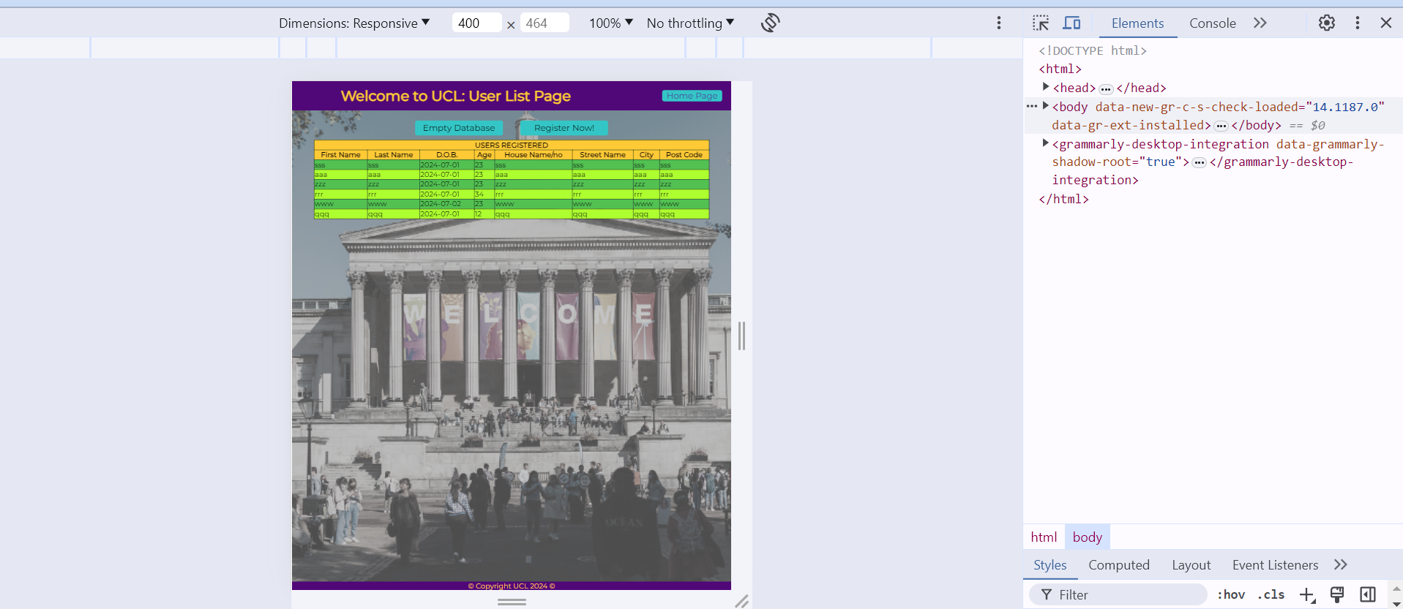

*Figure 19: Usage of Inspect Tool for Smartphone Dimension Checking*

The inspect tool is one of the tools that have been introduced during the process of this class. To ensure that the website is robust to various use cases, I utilised the inspect tool in order to proof-check the webpage actions under various conditions. It has come to assist in terms of styling the webpage more robustly and has been of great help in the process of designing the updated interface.

# Further Improvements

In my opinion, due to the time constraint, there is definitely a lot more that could have been accomplished to ensure that this web interface is more user-friendly and secure. Listed below are three different improvements that could have been implemented given more resources:

1. The development of a login system may prove to be useful, in order to safeguard the user list information from unwanted access.
2. Values inspection can be implemented to double-check the entries that users have keyed in for their registration. This is important to identify erroneous data and keep the database clean.
3. Further styling could be implemented to improve user experience. Some ideas may be the use of better and more standardised colour palettes.

# Reflection

During the process of implementing this webpage, I have gained a lot of experience in front-end development in particular. I developed my skills in CSS styling, HTML designing and creation, as well as the usage of JQuery in order to make the webpage more interactive and fun to engage with. The use of PHP to connect to a relational database also made the process more informative and meaningful, as it introduced me to how real-world databases interact with the websites that we see every day. These experiences in the development of web applications will prove to be essential in my future, as I proceed to pursue my career in data science and analytics.

# References

Google. (n.d.). *Montserrat*. Google Fonts. https://fonts.google.com/specimen/Montserrat

Ucl. (2024, March 6). *Colour palette*. UCL Brand. https://www.ucl.ac.uk/brand/brand-essentials/colour-palette

Study. (2024a, July 4). https://www.ucl.ac.uk/prospective-students/study

*W3schools.com*. W3Schools Online Web Tutorials. (n.d.). https://www.w3schools.com/sql/func_mysql_curdate.asp

# Appendix

Github repo:

Presentation video: